Design and Technology
Food and Clothing Product Design
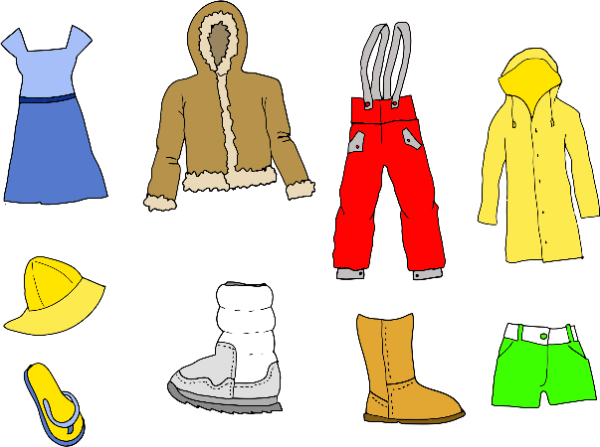
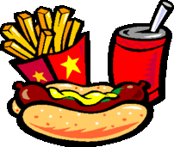

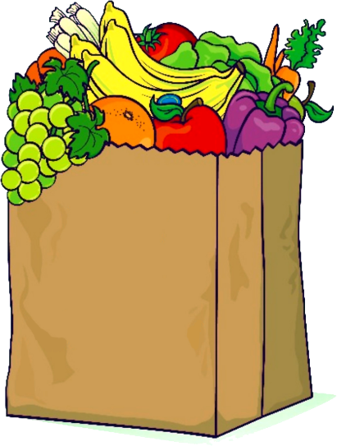

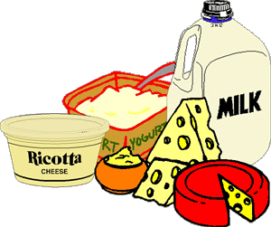
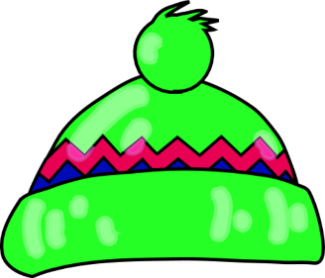

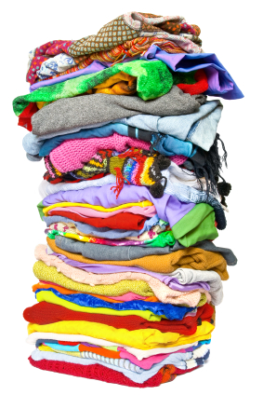
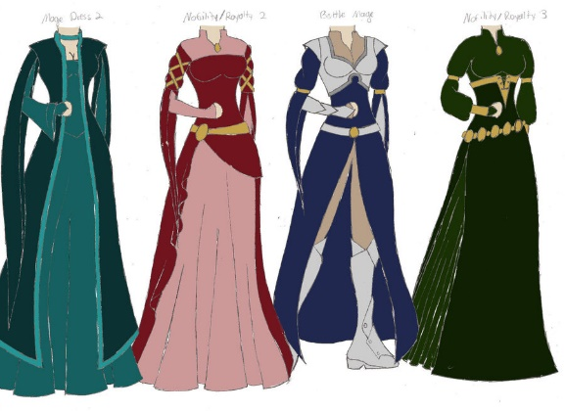

NOTE: This booklet needs to be printed
Activity 1
Look at the different products in front of you.
Name some of the products.
____________________________________________________________________________________________________________________________________________________________________________________________________________________________________
Name the different types of materials used for these products.
____________________________________________________________________________________________________________________________________________________________________________________________________________________________________
What are these products used for?
____________________________________________________________________________________________________________________________________________________________________________________________________________________________________
Who are these products for/ who is the target audience?
____________________________________________________________________________________________________________________________________________________________________________________________________________________________________
Are these products fit for their purpose? How?
____________________________________________________________________________________________________________________________________________________________________________________________________________________________________
Are the quality of the products good?
____________________________________________________________________________________________________________________________________________________________________________________________________________________________________
Draw and label a picture of the products you see

Activity 2
Plastic Wrapper | Plastic Container
Good for: | Good for:  Lunchbox  Packaging
Bad for: | Bad for:

2. Recently, the media has been talking about removing grocery bags from shopping centres because too many of the bags are ending up littered on our streets and in our oceans.
a) In your group, discuss why it would be a good idea to get rid of plastic shopping bags. ______________________________________________________________________________________________________________________________________________________________________________________________________________________________________________________________________________________________________________________________________________________

b) In your group, discuss why it would not be a good idea to get rid of plastic shopping bags.
______________________________________________________________________________________________________________________________________________________________________________________________________________________________________________________________________________________________________________________________________________________
c) What is your own personal opinion on the removal of plastic bags? Why do you think this?
____________________________________________________________________________________________________________________________________________________________________________________________________________________________________
d) With your group, discuss some other options there are for bagging groceries rather than using plastic shopping bags.
_____________________________________________________________________________________________________________________________________________________________________________________________________________________________________________________________________________________________
Activity 3
Look at the clothing materials in front of you.
Name the materials and describe what they would be used for
_______________________ - _________________________________ __________________________________________________________________________________________________________________
_______________________ - _________________________________ __________________________________________________________________________________________________________________
_______________________ - ________________________________ __________________________________________________________________________________________________________________
_______________________ - ________________________________ __________________________________________________________________________________________________________________
_______________________ - ________________________________ __________________________________________________________________________________________________________________
_______________________ - ________________________________ __________________________________________________________________________________________________________________
_______________________ - ________________________________ __________________________________________________________________________________________________________________

Describe where you have seen one of these materials used
___________________________________________________________________________________________________________________________________________________________________________
Using one of these materials, sketch and label a clothing item that would make good use of that material.

Final Task – Design your own product
Product Description
________________________________________________________________________________________________________________________________________________________________________________________________________________________________________________________________________________________________________________________________________________________________________
Labelled Diagram

To represent the materials that you would use, what types of materials are you using in their place?
_________________________________________________________________________________________________________________________________________________________________________________________________________________________________________________________________________________________________________________________________________________________________________________________________________________________________________________________________________________________________________________________________________________________________________________________________________________________________________________________________________________________________________________________________________________________________________________________________________________________________________________________________________________________________________________________________________________________________________________________________________
Steps taken in your product process with photos
Finished product
Changes
Putting together
Materials setup
Discussion and Reflection
- Who was the target audience for your product?
____________________________________________________________________________________________________________________
- Why/what would they use it for?
__________________________________________________________________________________________________________________
- What design solution does it meet?
__________________________________________________________________________________________________________________
- Did your product turn out like you had originally planned? In what way?
__________________________________________________________________________________________________________________
- What is something you liked about your design? Why?
___________________________________________________________________________________________________________________________________________________________________________
- What is something you did not like about your design? Why?
___________________________________________________________________________________________________________________________________________________________________________
- What is something that worked really well with your design? Why?
__________________________________________________________________________________________________________________
- What is something that did not work with your design? Why?
___________________________________________________________________________________________________________________________________________________________________________
- Did you have to make any changes in your design to make it work better? What were the changes?
___________________________________________________________________________________________________________________________________________________________________________
- If you had to do this activity again, what would you do differently?
__________________________________________________________________________________________________________________

