Digital Technologies
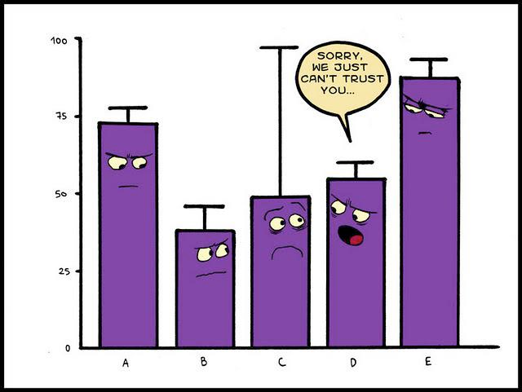
Collecting and Displaying Data
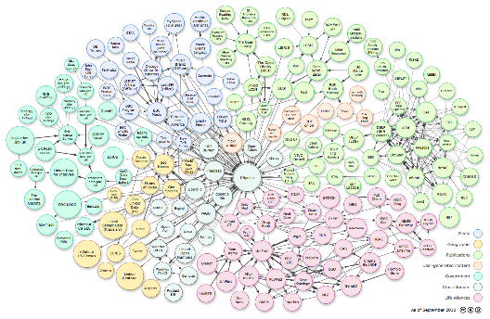

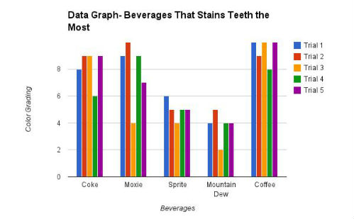
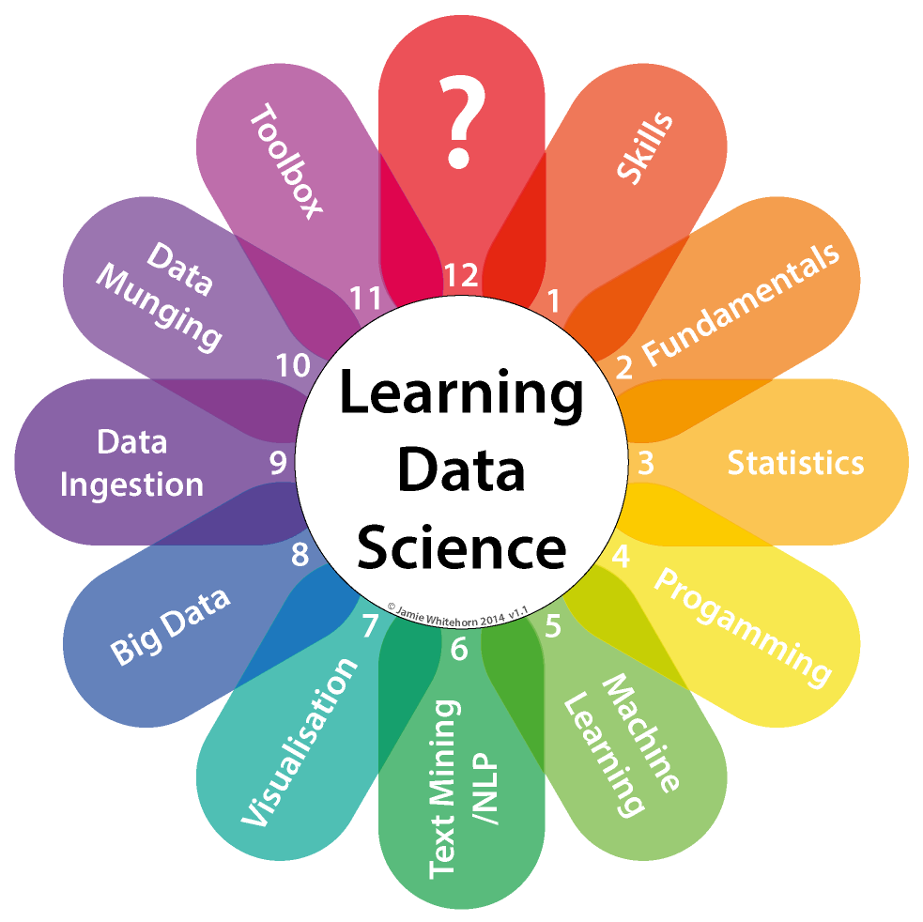

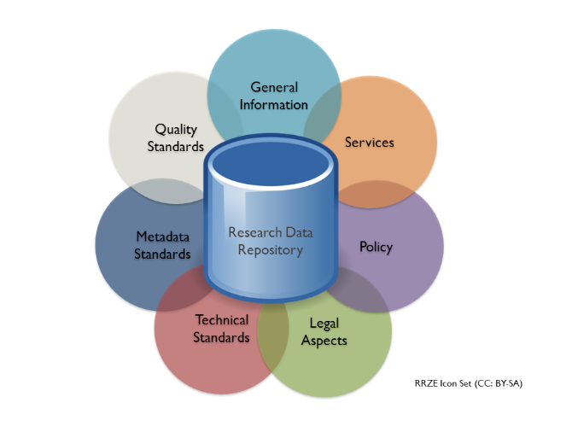

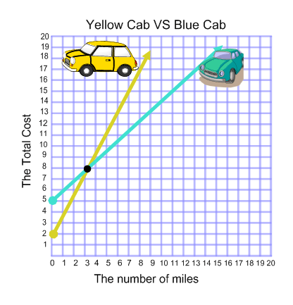
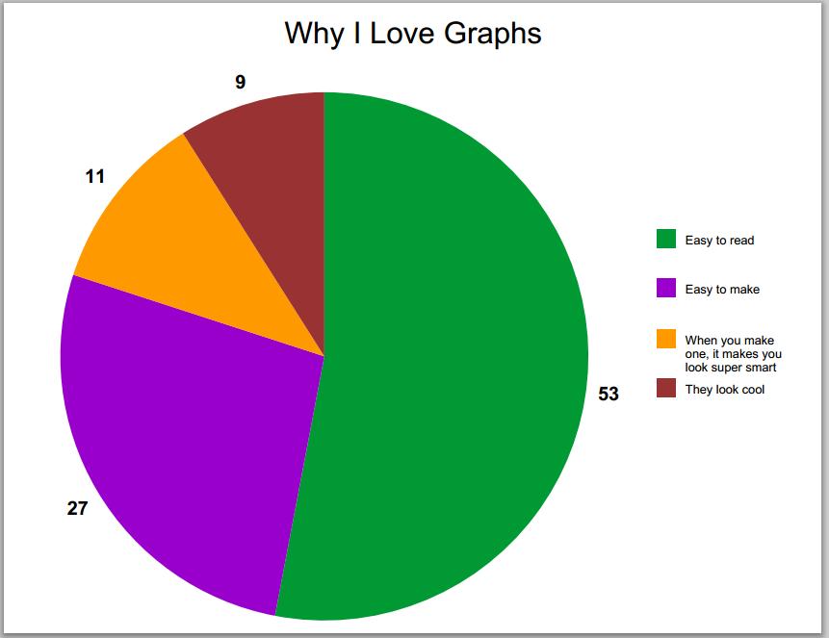

NOTE: This booklet does not need to be printed
Activity 1
- Help!! There are monsters in the classroom. Help the teacher get rid of all the monsters in the room by sorting them into their correct bags.
Click here to start

- Fuzz Bugs are everywhere! Sort the Fuzz Bugs into the tubes that are the same colour then complete some activities.
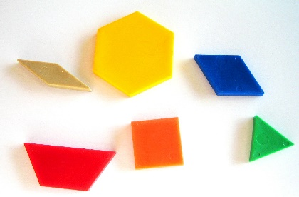
Click here to sort the Fuzz Bugs

- Get out the patterning blocks in your classroom and sort them into different categories.
Draw a labelled picture of how you sorted your blocks. Take a photo of that picture and insert it below.

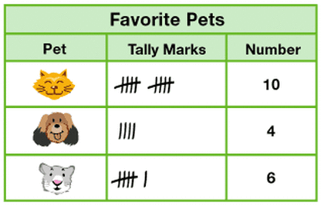
Activity 2

Looking at the above graph, answer these questions.
- What are the pets you can choose from?

- How are the results recorded?

- How many people were asked?

- How many people said that their favourite pet was a cat?

- How many more people liked cats than dogs?

The above survey data shows the pieces of fruit eaten each day by a class of students. Looking at the graph answer the following questions
- What are the different types of fruits that can be chosen?

- What does the key tell you?

- How many fruit serves were recorded?

- Which fruit is eaten most?

- Which fruit is eaten least?

- Is this an easy way of representing data? Why?
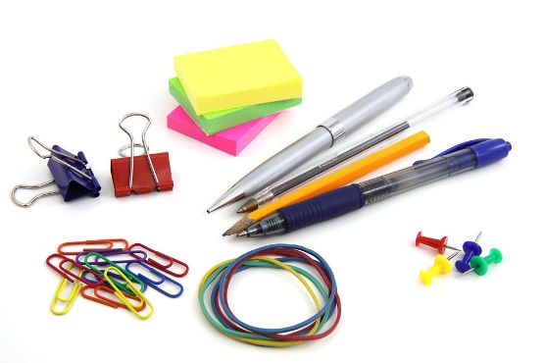
Activity 3
Step 1: Using the stationery items that you were given in your group, separate the items into different groups according to their diffferent features until there is only one item left in each group. Use the piece of paper and a pencil to show how you separated the items and to write what you separated them into
Step 2: In your group, using Bubbl, create a mind map that shows how you have categorised these items.
Step 3: Insert a picture of your groups mind map in the space below.

Activity 4
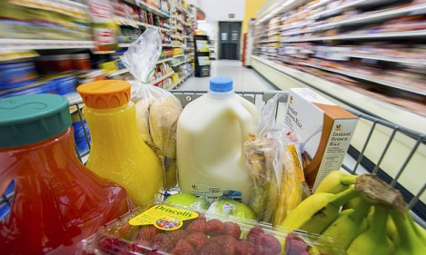
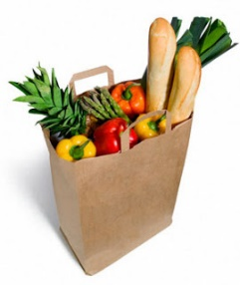
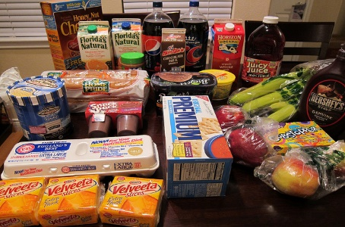

Looking at the food items in the class, list all the things that are similar or the same between the items.

How can you sort these items? What would you sort them into?

How can you represent this?

Choose one way of representing this data that can be done electronically below

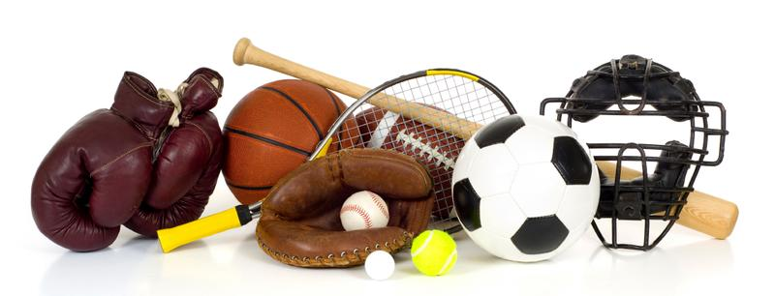
Final Activity
Undertake your own survey using the students in your class or school to find out what new piece of sports equipment the school should get.
Instructions:
- Give the people you survey a choice between sports equipment options you have already choosen OR allow them to decide their own
- Collect the data of no more than 25 people
- Display the data in a way that suits you
- Make sure that the data display is labelled
- State which piece of equipment is most wanted
Insert your data display here

What piece of sports equipment was most wanted?

How many people wanted it?

What have you learned through gathering and sorting data?

How does the use of digital technology help you display data?

What do you think surveys help you do?

